NAME: SAGARSUMAN P MANJHI SUBJECT: PYTHON PROGRAMMING LAB | PRACTICAL: 08 | BATCH : 04  SYBVOC :SEM-III (DS)
EXPERIMENT BASED ON REGULAR EXPRESSIONS

AIM : To study and implement regular expressions in Python for pattern matching, validation, searching, splitting, and text replacement by developing a User Registration Form Validator for email, phone number, password, and PIN code.
LEARNING OBJECTIVE :
  - To understand regular expressions in Python.
  - To learn the use of the re module.
  - To validate names, email addresses, phone numbers, passwords, and PIN codes.
  - To use regular expression functions for pattern matching.
  - To understand how to apply conditions for input validation.
  - To develop a user registration validation program.
TOOLS :
Sr. No. | Name Of Resources | Specification | Quantity | Remarks
1. | Hardware | Computer (i5-i7) Ram (Min 16GB) | 1 | For All Practical
2. | Software | Python / IDLE / VS Code | 1 | For All Practical
THEORY :
Regular expressions, also known as regex, are sequences of characters used to define search patterns. Python provides the built-in re module to perform pattern matching, validation, searching, splitting, and text replacement.
In this practical, a User Registration Form Validator is developed to check the validity of a user's name, email address, phone number, password, and six-digit PIN code.
Concepts Used
- Regular Expressions: Patterns used to match specific text formats.
- re Module: A built-in Python module for working with regular expressions.
- re.fullmatch(): Checks whether the entire string matches a specified pattern.
- strip(): Removes leading and trailing whitespace from a string.
- Conditional Statements: The if, elif, and else statements determine whether the entered details are valid.
- Raw Strings: Patterns prefixed with r make it easier to write regular expressions containing backslashes.
Syntax
import re
if re.fullmatch(pattern, text):
print("Valid")
else:
print("Invalid")
Source Code:
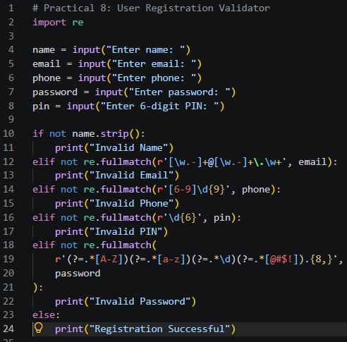
Output:
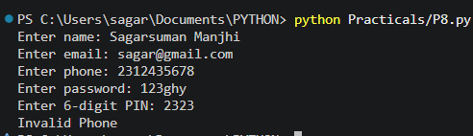
Result and Discussion:
The User Registration Form Validator was implemented successfully using Python regular expressions and the re module.
The program validates the following details:
- Name: Checks that the name is not empty or composed entirely of whitespace.
- Email: Checks the basic email format, including an @ symbol and a domain suffix.
- Phone Number: Checks for a ten-digit Indian mobile number beginning with a digit from 6 to 9.
- PIN Code: Checks that the PIN contains exactly six digits.
- Password: Requires at least eight characters, one uppercase letter, one lowercase letter, one digit, and one special character from @, #, $, or !.
Learning Outcomes:
- Learned to import and use the re module.
- Applied re.fullmatch() to validate input formats.
- Implemented validation for email, phone number, password, and PIN code.
- Used conditional statements to manage validation results.
- Developed a basic registration validation program in Python.
Course Outcomes:
- Understand regular expressions and their applications in Python.
- Apply pattern matching to validate user input.
- Use Python's built-in modules for text processing.
- Develop a registration validator using conditional statements and regular expressions.
CONCLUSION :
The User Registration Form Validator was developed successfully using Python regular expressions. The program validates the user's name, email address, phone number, password, and six-digit PIN code. This practical demonstrates how regular expressions can be used to perform input validation and improve the reliability of user registration programs.

VIVA QUESTIONS :
Q1. What is a regular expression?
A regular expression is a pattern used to search, match, or validate text.
Q2. Which module is used for regular expressions in Python?
The built-in re module is used.
Q3. What is the purpose of re.fullmatch()?
It checks whether the entire input string matches the specified pattern.
Q4. What does \d represent in a regular expression?
It matches a digit.
Q5. What does \d{6} mean?
It matches exactly six digits.
Q6. What is the purpose of [A-Z]?
It matches an uppercase English letter from A to Z.
FOR FACULTY USE ONLY :
Correction Parameters | Formative Assessment [40%] | Timely completion of practical [40%] | Attendance/ Learning Attitude [20%]
Marks Obtained

